**Sentiment Analysis For Marketing**

**Project Title: Sentiment Analysis For Marketing**

**Phase 3: Development Part 1**

**Topic: Building your project by loading and preprocessing the dataset**

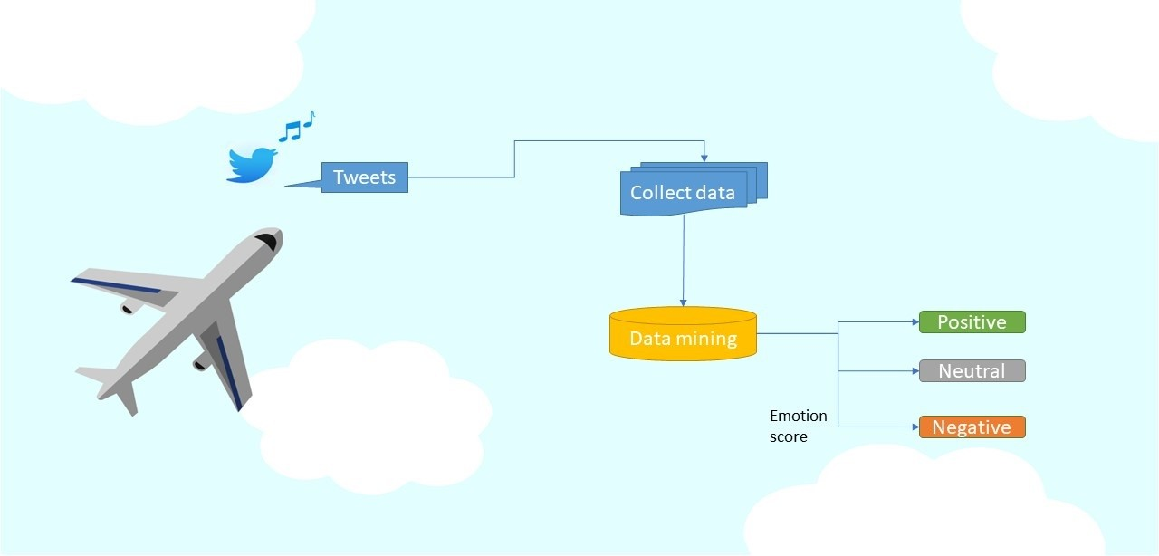

**Sentiment analysis for marketing**

**Introduction:**

Sentiment analysis for marketing using AI can be a powerful tool for gathering insights about how customers and potential customers feel about your products, services, or brand. This information can be valuable for marketing and product development. Here's a high-level overview of how AI can be used in both areas:

1. **Sentiment Analysis for Marketing:**

a. **Data Collection:** AI tools can scrape data from various sources, including social media, online reviews, customer feedback forms, and surveys.

b. **Text Preprocessing:** Natural Language Processing (NLP) techniques are used to clean and preprocess the collected text data. This includes tasks like tokenization, stemming, and removing stop words.

c. **Sentiment Analysis Model:** Develop or deploy a sentiment analysis model. This model can be based on pre-trained models like BERT or can be trained on custom datasets.

d. **Sentiment Classification:** Apply the model to classify text into positive, negative, or neutral sentiment categories. This can provide you with insights into how customers perceive your brand, products, or services.

e. **Keyword and Topic Analysis:** AI can also help identify keywords and topics that frequently appear in positive or negative sentiment contexts. This can inform your content strategy and marketing campaigns.

f. **Real-time Monitoring:** Continuously monitor social media and online platforms to track sentiment changes in real-time. This allows you to respond promptly to emerging issues or positive trends.

g. **Competitive Analysis:** Compare the sentiment of your brand with that of competitors to gain a competitive edge.

Given data set:

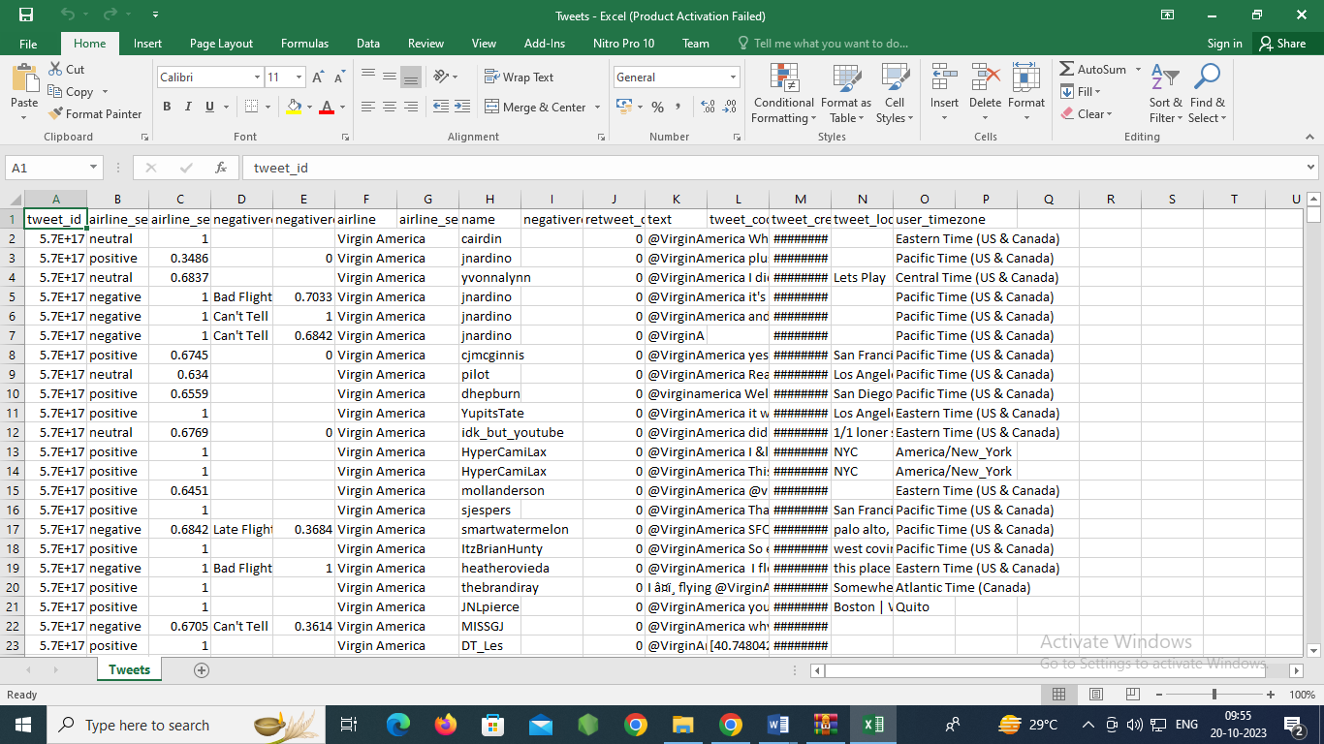

**5000 Rows x 7 Columns**

**Necessary step to follow:**

**1.Import Libraries:**

Start by importing the necessary libraries:

**Program:**

import pandas as pd

import numpy as np

from sklearn.model_selection import train_test_split

from sklearn.preprocessing import StandardScaler

**2.Load the Dataset:**

Load your dataset into a Pandas DataFrame. You can typically find

house price datasets in CSV format, but you can adapt this code to other

formats as needed.

**Program:**

df = pd.read_csv(' E:\tweets.csv ')

Pd.read()

**3. Exploratory Data Analysis (EDA):**

Perform EDA to understand your data better. This includes

checking for missing values, exploring the data's statistics, and

visualizing it to identify patterns.

**Program:**

# Check for missing values

print(df.isnull().sum())

# Explore statistics

print(df.describe())

# Visualize the data (e.g., histograms, scatter plots, etc.)

**4. Feature Engineering:**

Depending on your dataset, you may need to create new features or

transform existing ones. This can involve one-hot encoding categorical

variables, handling date/time data, or scaling numerical features.

**Program:**

**5. Split the Data:**

Split your dataset into training and testing sets. This helps you evaluate

your model's performance later.

X = df.drop('price', axis=1) # Features

y = df['price'] # Target variable

X_train, X_test, y_train, y_test = train_test_split(X, y, test_size=0.2,

random_state=42)

**6. Feature Scaling:**

Apply feature scaling to normalize your data, ensuring that all

features have similar scales. Standardization (scaling to mean=0 and

std=1) is a common choice.

**Program:**

scaler = StandardScaler()

X_train = scaler.fit_transform(X_train)

X_test = scaler.transform(X_test)

**Importance of loading and processing dataset:**

Loading and preprocessing the dataset is an important first step in

building any machine learning model. However, it is especially

important for house price prediction models, as house price datasets are

often complex and noisy.

By loading and preprocessing the dataset, we can ensure that the

machine learning algorithm is able to learn from the data effectively and

accurately.

**Challenges involved in loading and preprocessing a airline sentiment dataset:**

1. **Data Volume and Quality: Loading and preprocessing an airline sentiment dataset can be challenging due to the large volume of data and its quality. These datasets often contain thousands of tweets or reviews, and cleaning and verifying the quality of the text data can be time-consuming. Data may include misspellings, noisy text, or irrelevant information, which need to be addressed to ensure accurate analysis.**
2. **Text Data Preprocessing: Text data preprocessing involves several tasks such as tokenization, stop-word removal, stemming, and lemmatization. Handling different languages and variations in sentiment expressions can be complex. Additionally, sentiment labels may not be consistent or may require mapping to a standardized sentiment scale, adding another layer of complexity.**
3. **Imbalanced Class Distribution: Airline sentiment datasets often suffer from imbalanced class distribution, where the number of positive, negative, and neutral sentiments may vary significantly. This imbalance can impact the training and evaluation of sentiment analysis models, requiring techniques such as oversampling, undersampling, or using specialized algorithms to address the issue and ensure accurate sentiment predictions.**

**How to overcome the challenges of loading and preprocessing a**

**Airline sentiment dataset:**

**Loading and preprocessing an airline sentiment dataset can be a challenging task, but with the right approach, you can make the process more manageable. Here are steps to help you overcome the challenges:**

1. **Understand the Dataset:**
   * **First, thoroughly understand the structure of the dataset. This includes the format, file type (CSV, JSON, etc.), and the meaning of each column.**
2. **Data Collection:**
   * **Ensure you have access to the dataset. If it's not publicly available, you may need to obtain the data through legal means.**
3. **Data Cleaning:**
   * **Before you can preprocess the data, you need to clean it. Common data cleaning tasks include handling missing values, removing duplicates, and correcting data entry errors. For sentiment analysis, focus on the text data and the sentiment labels.**
4. **Text Preprocessing:**
   * **For the text data, you should perform various preprocessing steps, including:**
     + **Tokenization: Splitting text into words or subword tokens.**
     + **Lowercasing: Convert all text to lowercase to ensure uniformity.**
     + **Removing Stopwords: Words like "the," "and," "is" often carry little meaning.**

Top of Form

1.Loading the dataset:

* Loading the dataset using machine learning is the process of bringing

the data into the machine learning environment so that it can be used

to train and evaluate a model.

* The specific steps involved in loading the dataset will vary depending

on the machine learning library or framework that is being used.

However, there are some general steps that are common to most

machine learning frameworks:

**a.Identify the dataset:**

The first step is to identify the dataset that you want to load. This

dataset may be stored in a local file, in a database, or in a cloud storage

service.

**b.Load the dataset:**

Once you have identified the dataset, you need to load it into the

machine learning environment. This may involve using a built-in

function in the machine learning library, or it may involve writing your

own code.

**c.Preprocess the dataset:**

Once the dataset is loaded into the machine learning environment,

you may need to preprocess it before you can start training and

evaluating your model. This may involve cleaning the data, transforming

the data into a suitable format, and splitting the data into training and

test sets.

Here, how to load a dataset using machine learning in Python

**Program:**

import pandas as pd

import numpy as np

import seaborn as sns

import matplotlib.pyplot as plt

from sklearn.model_selection import train_test_split

from sklearn.preprocessing import StandardScaler

from sklearn.metrics import r2_score,

mean_absolute_error,mean_squared_error

from sklearn.linear_model import LinearRegression

from sklearn.linear_model import Lasso

from sklearn.ensemble import RandomForestRegressor

from sklearn.svm import SVR

import xgboost as xg

%matplotlib inline

import warnings

warnings.filterwarnings("ignore")

/opt/conda/lib/python3.10/site-packages/scipy/__init__.py:146:

UserWarning: A NumPy version >=1.16.5 and <1.23.0 is required for

this version of SciPy (detected version 1.23.5

warnings.warn(f"A NumPy version >={np_minversion} and

<{np_maxversion}"

Loading Dataset:

dataset = pd.read_csv('E:/tweets.csv')

Data Exploration:

**Dataset:**

**Output:**

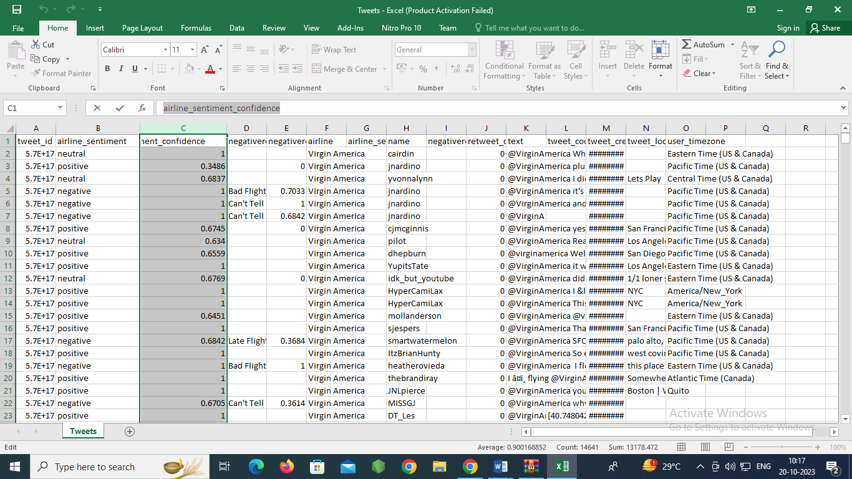

**2.Preprocessing the dataset:**

* Data preprocessing is the process of cleaning, transforming, and

integrating data in order to make it ready for analysis.

* This may involve removing errors and inconsistencies, handling

missing values, transforming the data into a consistent format, and

scaling the data to a suitable range.

**Some common data preprocessing tasks include:**

* Data cleaning: This involves identifying and correcting errors and

inconsistencies in the data. For example, this may involve

removing duplicate records, correcting typos, and filling in missing

values.

* Data transformation: This involves converting the data into a

format that is suitable for the analysis task. For example, this may

involve converting categorical data to numerical data, or scaling

the data to a suitable range.

* Feature engineering: This involves creating new features from

the existing data. For example, this may involve creating features

that represent interactions between variables, or features that

represent summary statistics of the data.

* Data integration: This involves combining data from multiple

sources into a single dataset. This may involve resolving

inconsistencies in the data, such as different data formats or

different variable names.

Data preprocessing is an essential step in many data

science projects. By carefully preprocessing the data, data scientists can

improve the accuracy and reliability of their results.

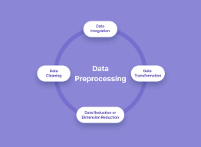

**Conclusion:**

**In conclusion, sentiment analysis for airline sentiment using AI is a powerful tool that enables airlines to gain valuable insights into customer opinions and experiences. It allows for real-time monitoring of customer sentiment, which can be used to improve services, address issues promptly, and enhance customer satisfaction. By leveraging natural language processing and machine learning techniques, AI can analyze large volumes of customer feedback efficiently and accurately, providing airlines with the ability to make data-driven decisions and maintain a positive brand image**.

**Thank you..,**